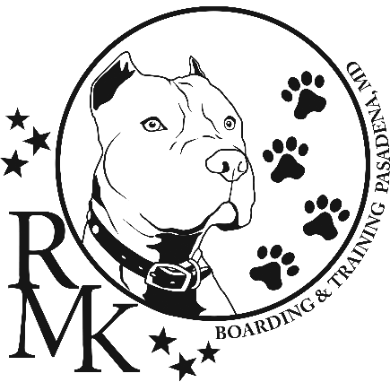

TRAINING PACKETS
____ One-on-One Obedience Packet #1 (6wks private lessons)
____ In-Home Training Packet #2 ($100 – 1hr Consultation Fee)

ENROLLMENT INFORMATION
Owner’s Name: _________________________________ Phone: ______________________
Dog’s Name: ______________________________ Breed:___________________________________
Age of Dog:____________ Sex: M or F Spayed/Neutered: Y or N

PROOF OF VACCINES: Rabies Vaccine and Bordetella
Packets are established as applications are received. A detailed summary with starting date and time of class will be sent to you via e-mail. Packet # 1 & #2 are held Tues-Frid any time after 6pm – until sunset or weekends early morning/late evenings (weather depending). Payment due on the 1st schedule lesson date.
Owner/Guardian: Date: ________

Handler/Guardian: Date: ________

**JUNIOR HANDLERS MUST BE STRONG ENOUGH, IN THE OPINION OF RMK, TO CONTROL THE DOG.**

**RMK RESERVES THE RIGHT TO EXCUSE ANY DOG OR HANDLER WHICH, IN THE OPINION OF RMK, MAY BE DANGEROUS TO OTHERS.**

